-SCREENSHOTS OF OUTPUTS FOR CORRESPONDING PROGRAMMES-

1. SIMPLE INTEREST

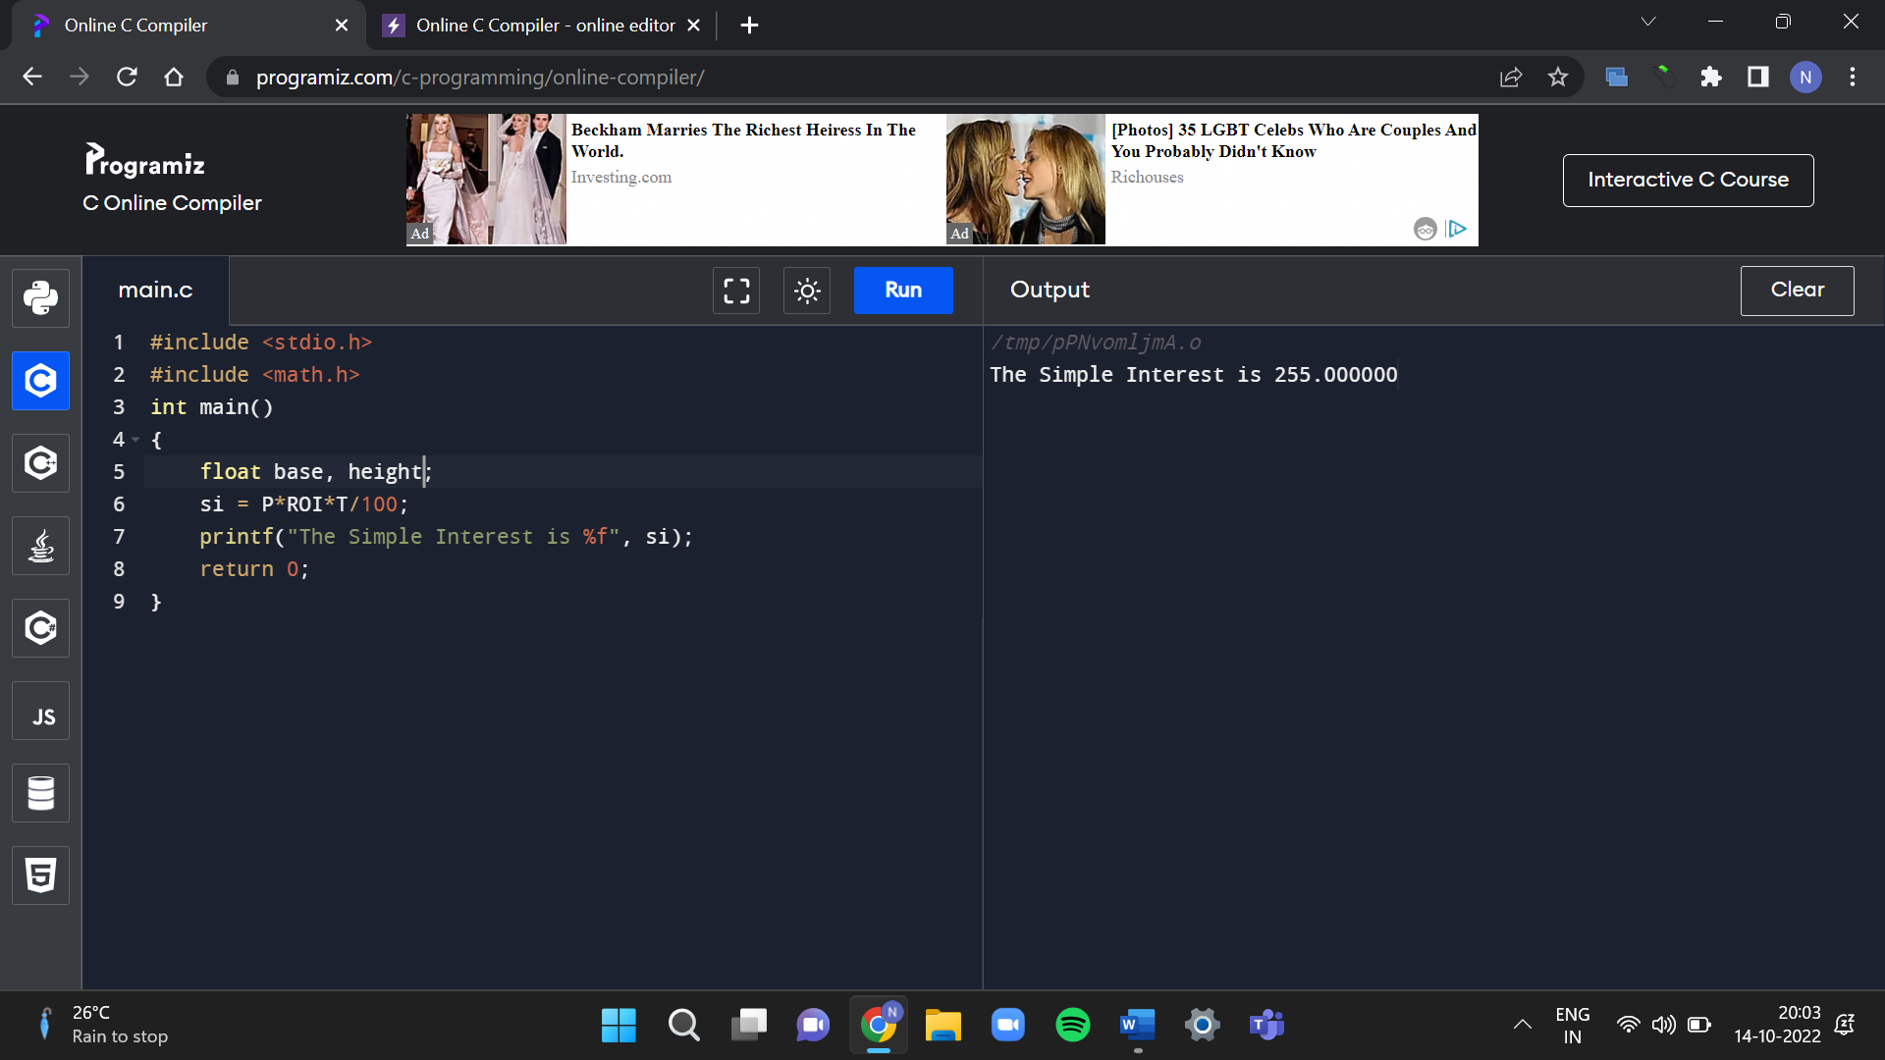

2. AREA OF TRIANGLE

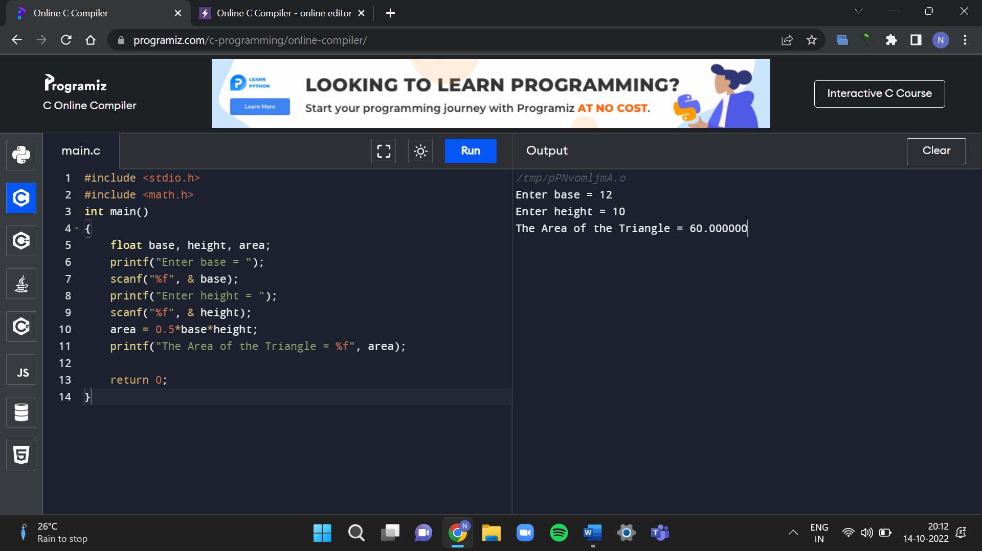

3. AREA OF SQUARE

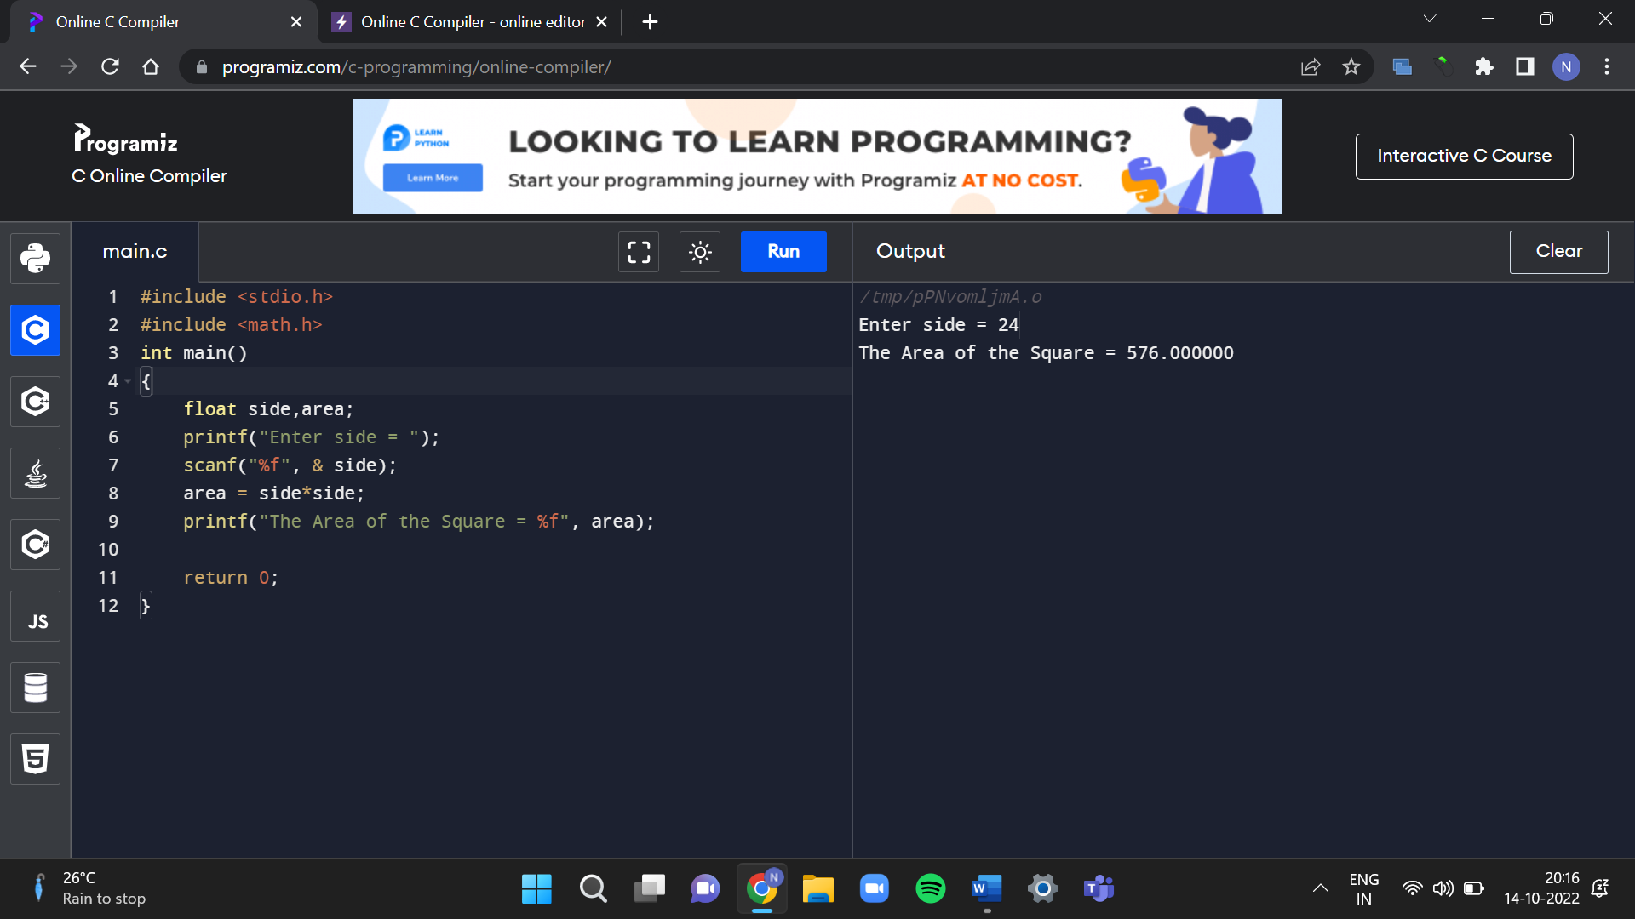

4. AREA OF RECTANGLE

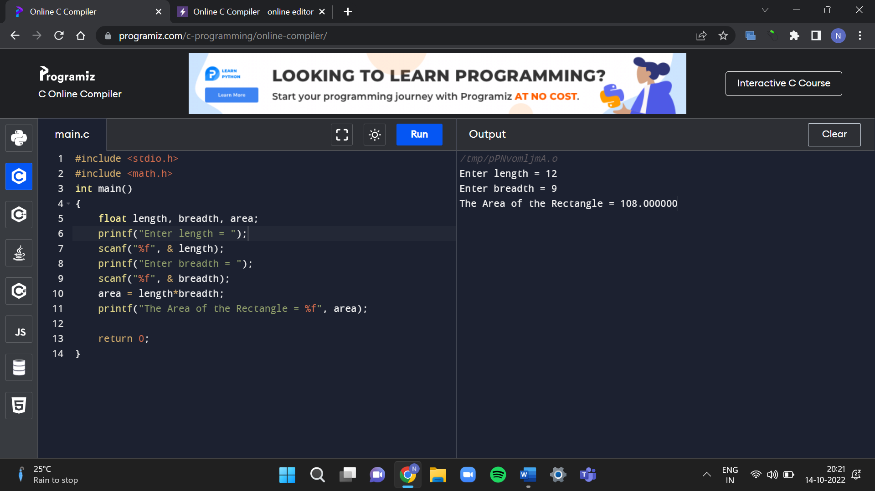

5. AREA OF CIRCLE

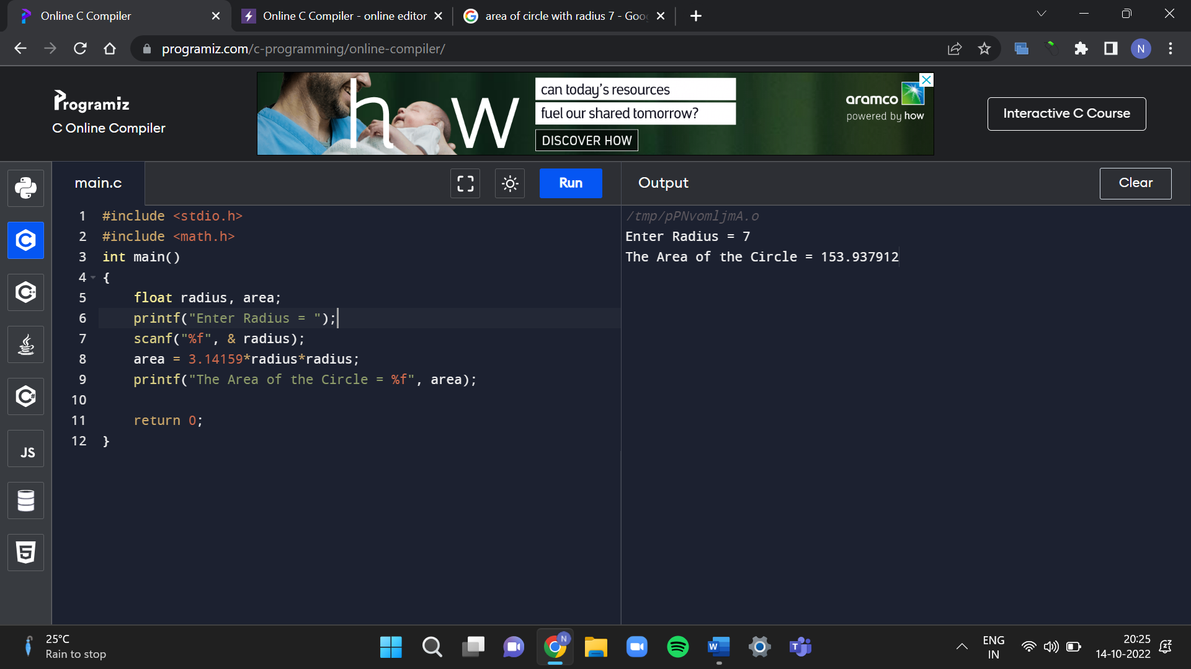

6. CIRCUMFERENCE OF A CIRCLE

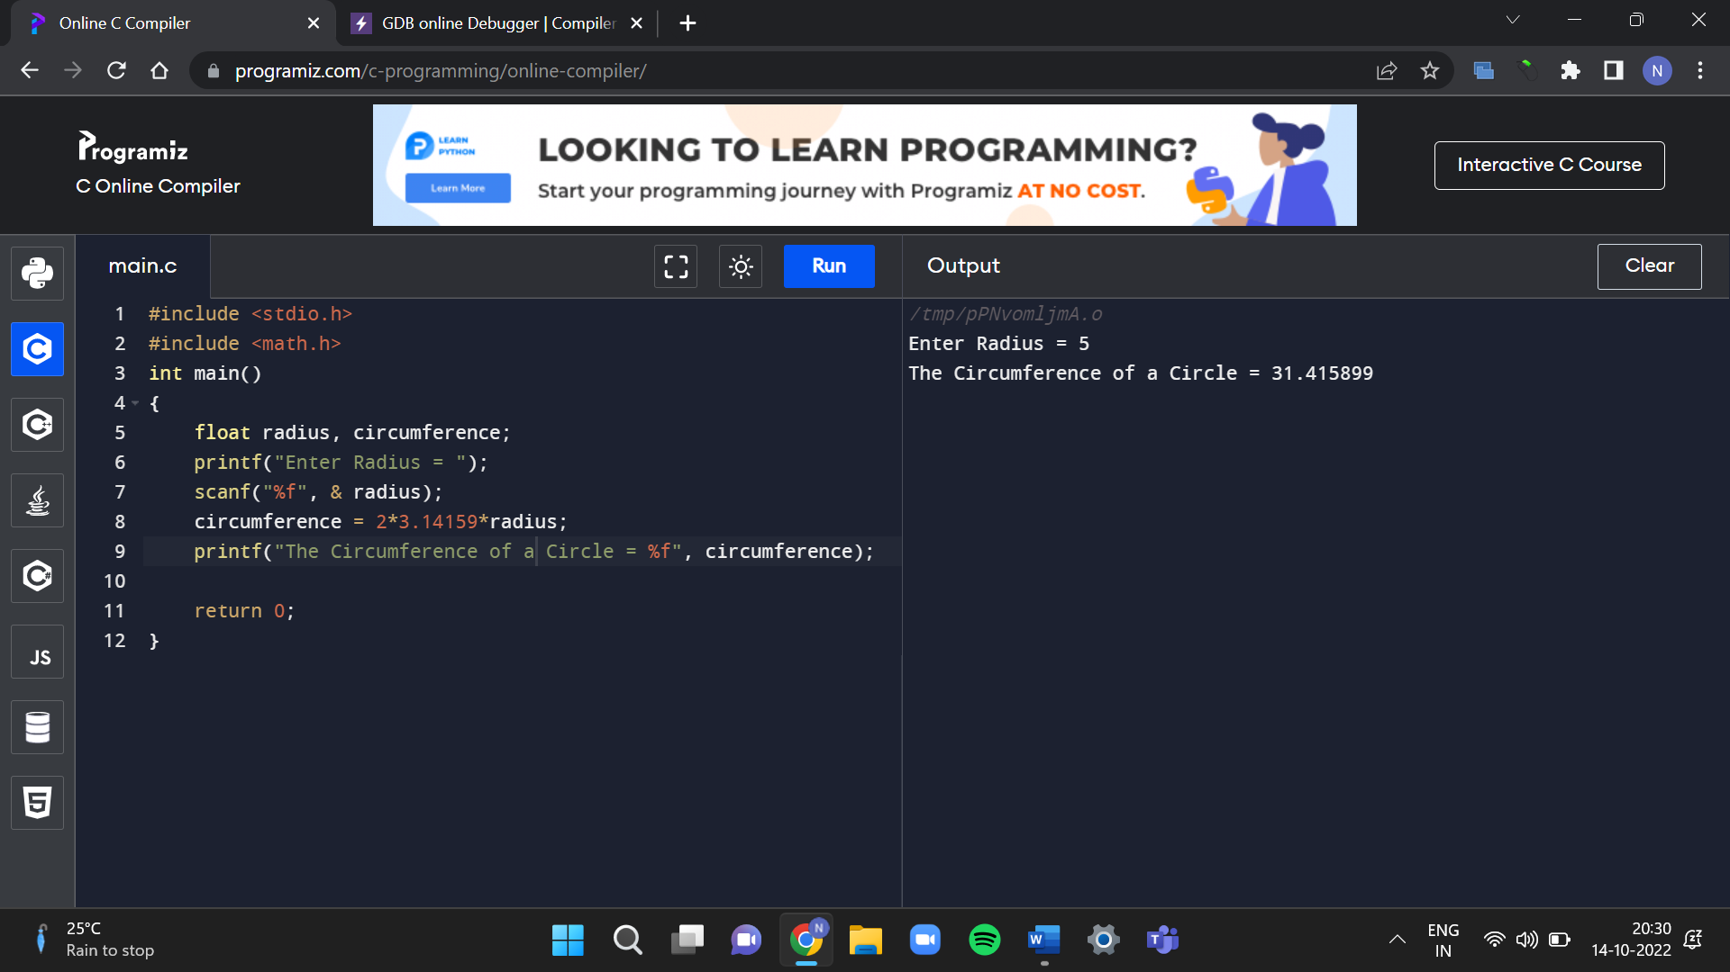

7. CALCULATE THE EMI

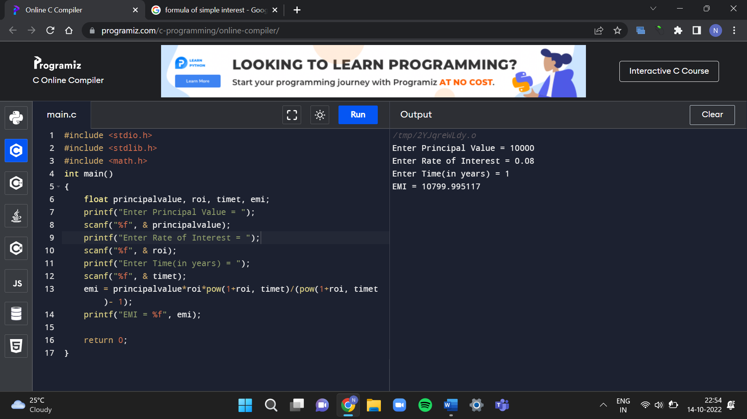

8. DEMONSTRATION OF IF STATEMENT

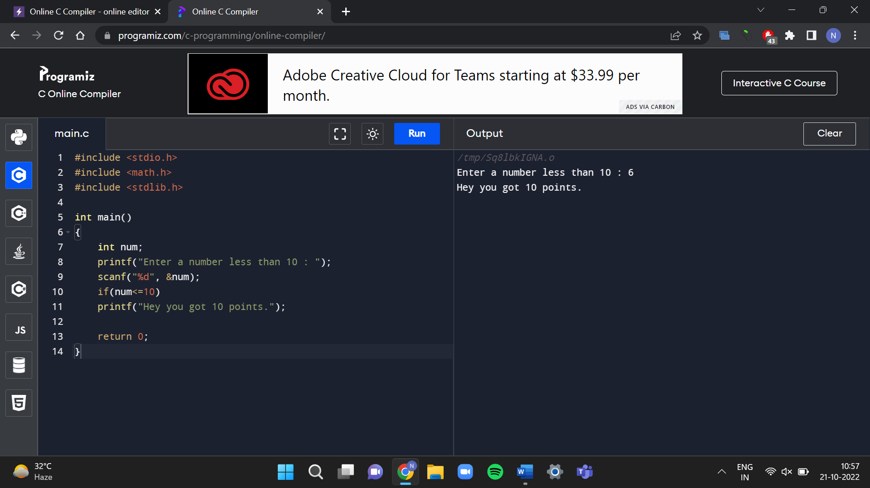

9. IF & ELSE STATEMENT

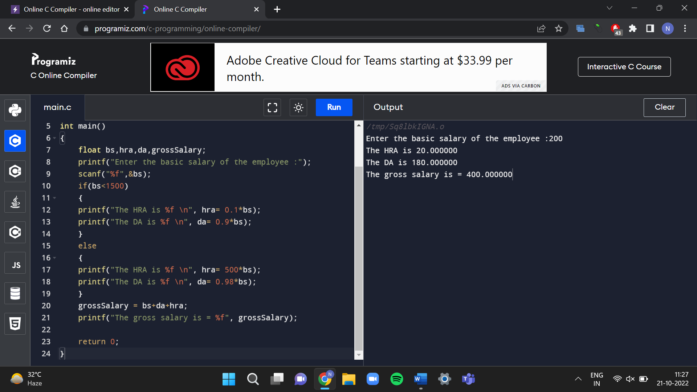

10. IF, ELSE & ELSE-IF STATEMENT

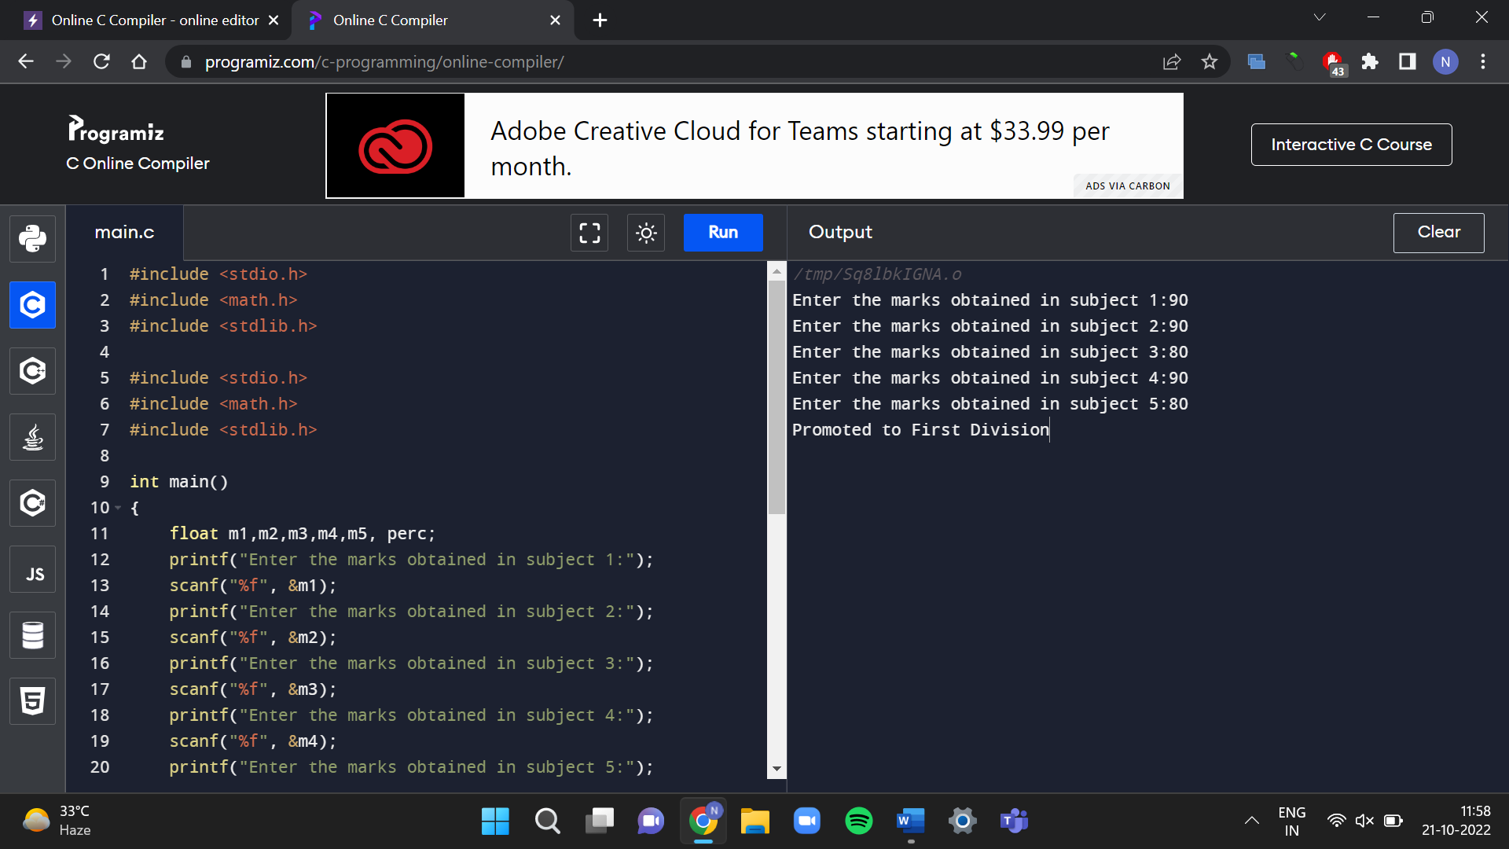

11. PROGRAM TO ACCEPT THREE NUMBERS FROM THE USER AND FIND THE LARGEST ONE(EXP-1)

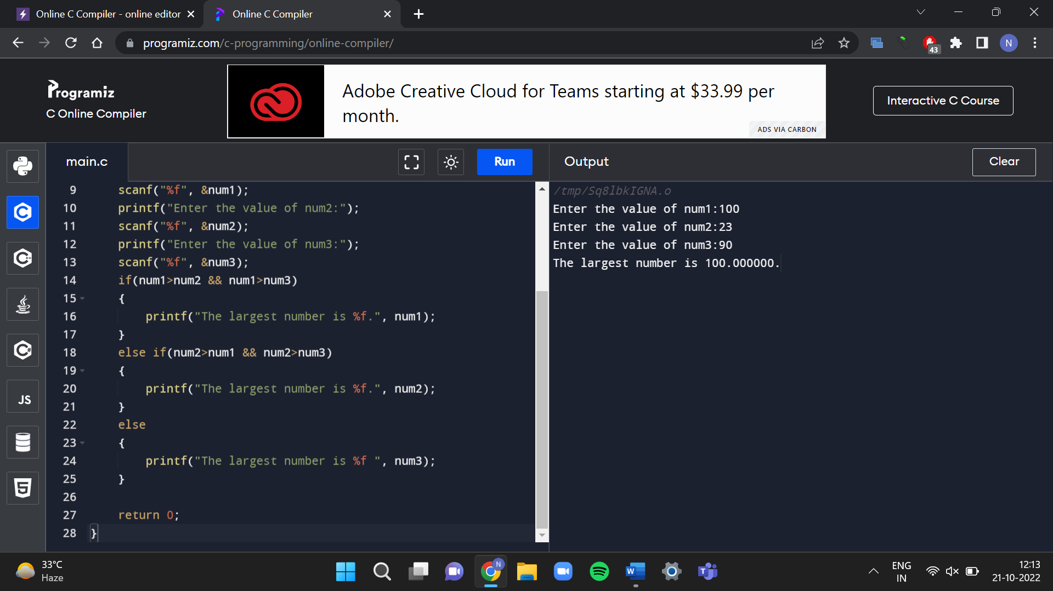

12. PROGRAM TO ACCEPT THREE NUMBERS FROM THE USER AND FIND THE LARGEST ONE USING TERNARY OPERATOR

